**Files and Description –**

1. CM_MKT_TRAD_GD_ZS.csv – Contains the values for stocks traded as total value (% of GDP) for the given countries for the time period 1960 to 2022.
2. CM_MKT_TRNR.csv – Contains the values for stocks traded as turnover ratio of domestic shares (%) for the given countries for the time period 1960 to 2022.
3. Country_CM_MKT_TRAD_GD_ZS.csv – Metadata about the given countries.
4. Country_CM_MKT_TRNR.csv – Metadata about the given countries.
5. Indicator_CM_MKT_TRAD_GD_ZS.csv – Metadata about the given indicator CM_MKT_TRAD_GD_ZS.
6. Indicator_CM_MKT_TRNR.csv – Metadata about the given indicator CM_MKT_TRNR.

**Staging Design –**

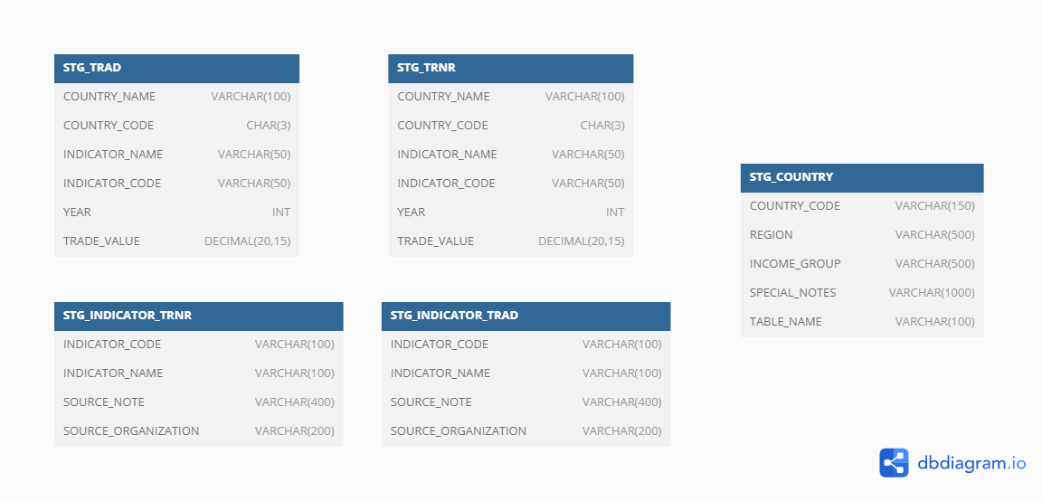

**Warehouse Design –**

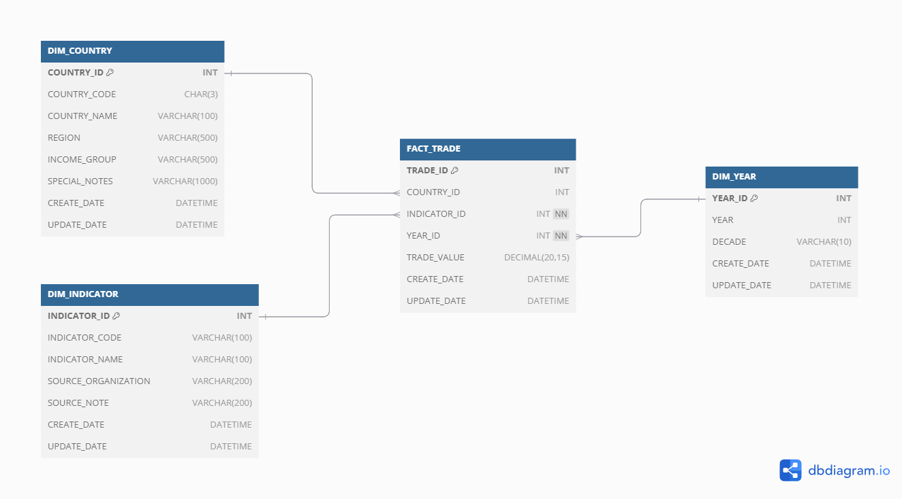

**Mappings Explained –**

**1. CM_MKT_TRAD_GD_ZS.csv to STG_TRAD:**

The CM_MKT_TRAD_GD_ZS.csv file contains year columns that need to be unpivoted. We achieve this by using the Normalizer transformation, which unpivots the year columns into a normalized format, making each row represent a single year’s trade data for each country.

We then use an Expression transformation to convert the GCID (Global Country Identifier) into the corresponding YEAR column.

This transformed data is then loaded into the STG_TRAD staging table for further processing.

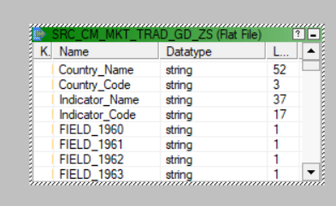

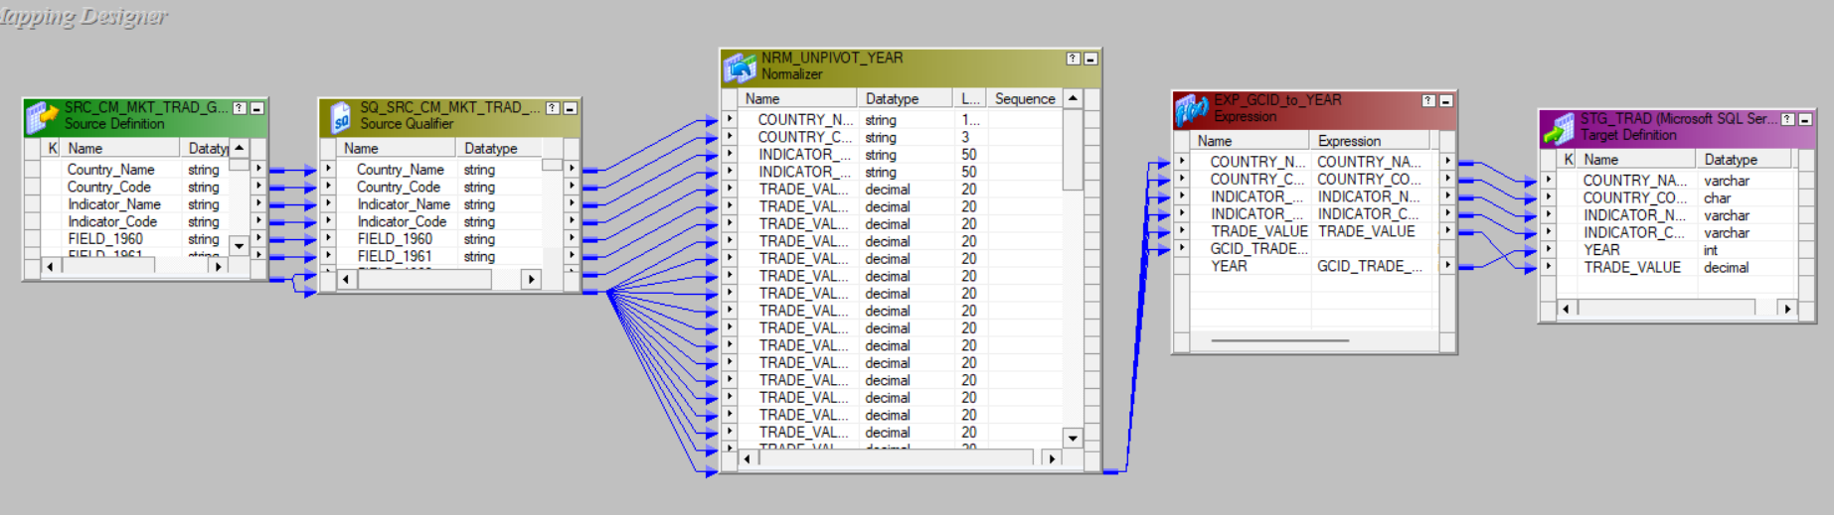

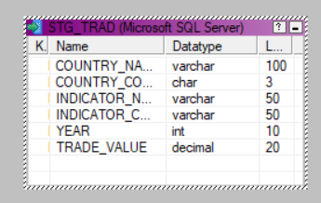

**2. CM_MKT_TRNR.csv to STG_TRNR:**

The process for the CM_MKT_TRNR.csv file is identical to the CM_MKT_TRAD_GD_ZS.csv process. The year columns are unpivoted using the Normalizer, GCID is converted into the YEAR column using an Expression, and the data is loaded into STG_TRNR.

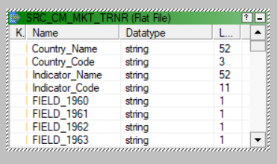

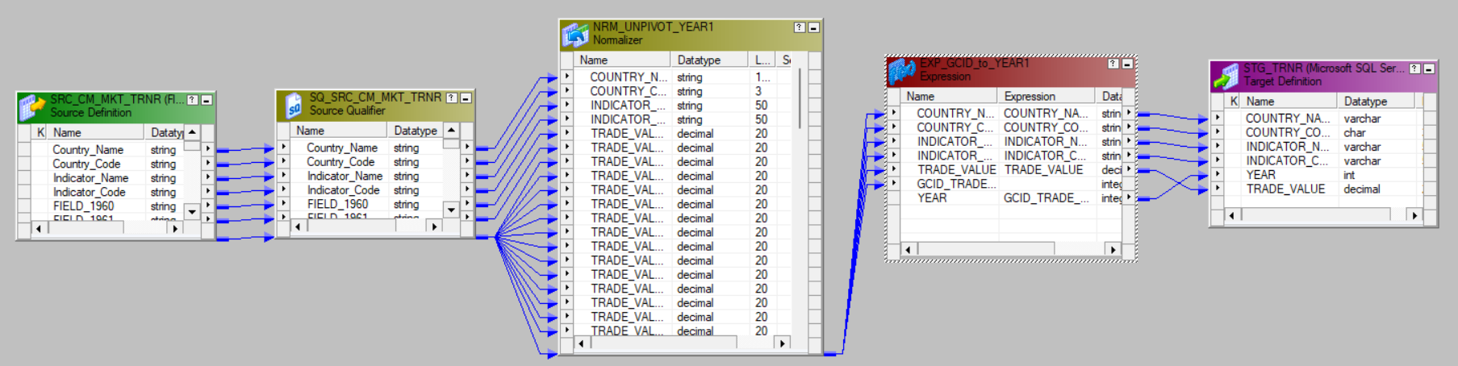

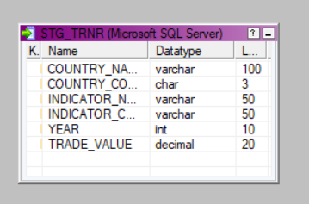

**3. Country_CM_MKT_TRAD_GD_ZS.csv to STG_COUNTRY:**

Upon analysis, we observe that the Country_CM_MKT_TRAD_GD_ZS.csv and Country_CM_MKT_TRNR.csv files are identical, so we choose to use Country_CM_MKT_TRAD_GD_ZS.csv exclusively for creating the STG_COUNTRY table.

Due to the presence of multiline records in the Country_CM_MKT_TRAD_GD_ZS.csv file, we configure the row delimiter as "\015 CR (\r)" in the source definition.

We utilize an Expression transformation to ensure the COUNTRY_CODE is in the correct format, removing any unwanted characters such as leading/trailing spaces or quotes.

A Filter transformation is then used to ensure that no records with a NULL COUNTRY_CODE are inserted into STG_COUNTRY.

Finally, the cleaned data is loaded into the STG_COUNTRY staging table.

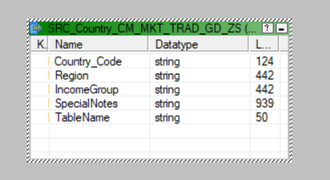

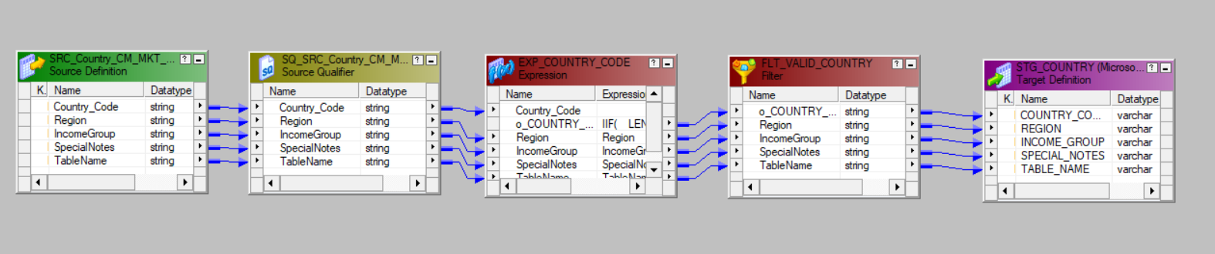

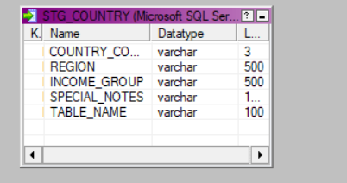

**4. Indicator_CM_MKT_TRAD_GD_ZS.csv to STG_INDICATOR_TRAD and Indicator_CM_MKT_TRNR.csv to STG_INDICATOR_TRNR:**

Indicator_CM_MKT_TRAD_GD_ZS.csv is loaded into the STG_INDICATOR_TRAD table, while Indicator_CM_MKT_TRNR.csv is loaded into STG_INDICATOR_TRNR.

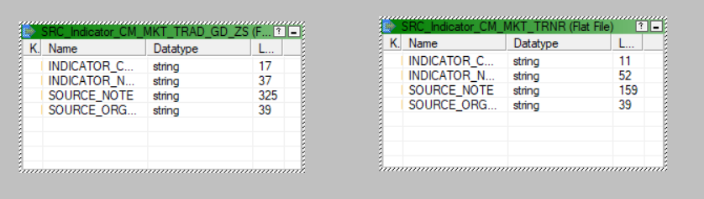

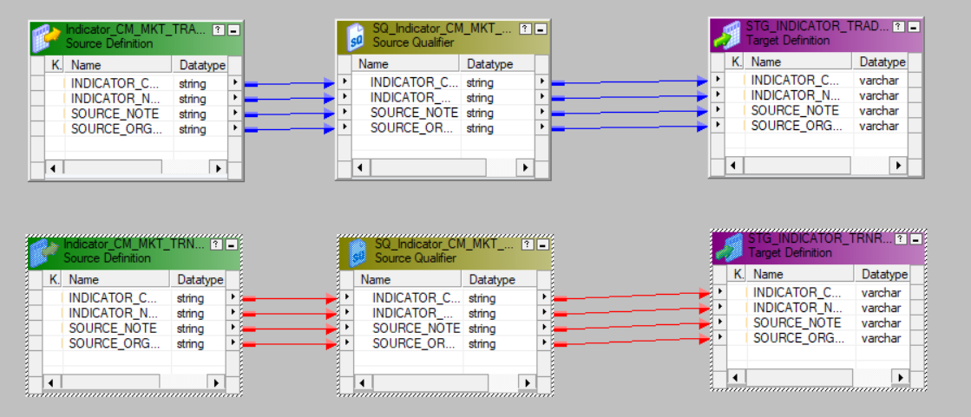

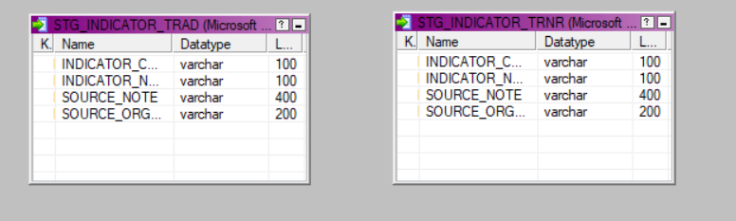

**5. From STG_TRAD to DIM_YEAR:**

We extract the YEAR column from STG_TRAD and use an Aggregator transformation to get unique year values. This ensures we do not have duplicate years in the system.

A Lookup transformation is performed on the DIM_YEAR table to check if the year already exists.

If the year does not exist in DIM_YEAR, an Expression transformation is used to derive the DECADE based on the YEAR.

The record is then loaded into the DIM_YEAR table, along with the CREATE_DATE and UPDATE_DATE.

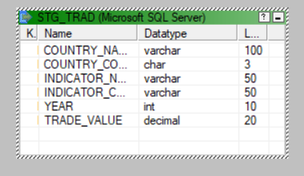

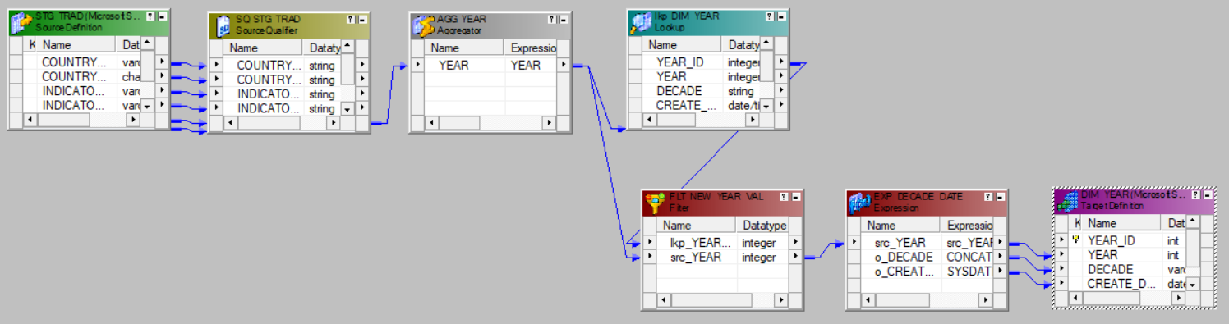

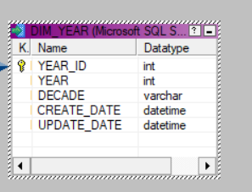

**6. From STG_COUNTRY to DIM_COUNTRY:**

We perform a Lookup transformation on DIM_COUNTRY to check if the record already exists.

The Expression transformation is used to check whether the record should be inserted, updated, or deleted.

A Router transformation routes records based on whether they are new, require updates, or need to be deleted.

The Update Strategy transformation is used to specify whether the record should be inserted or updated, and the record is then processed into DIM_COUNTRY.

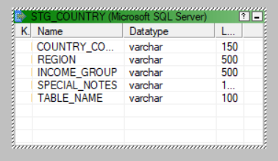

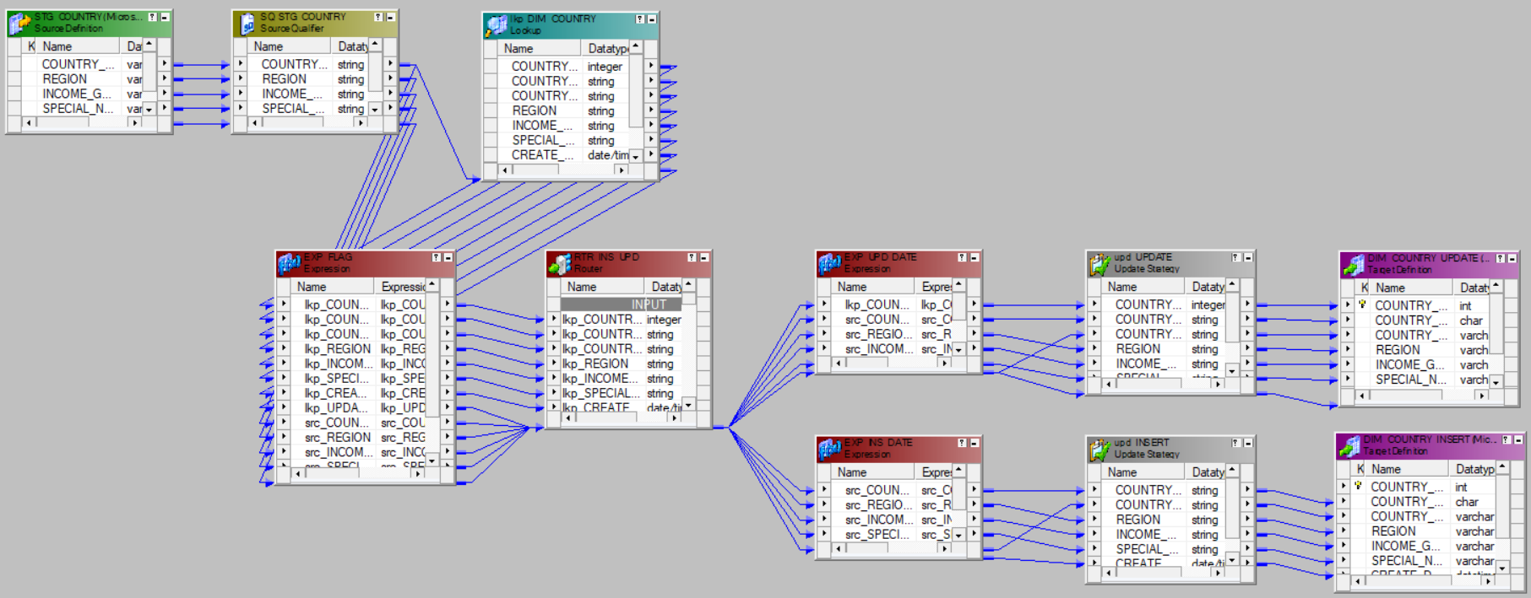

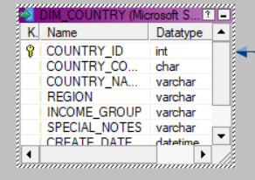

**7. From STG_INDICATOR_TRAD to DIM_INDICATOR:**

The process for STG_INDICATOR_TRAD is similar to that of STG_COUNTRY. We use Lookup to check for existing records in DIM_INDICATOR, followed by Expression and Router transformations to manage new, updated, and deleted records, and then load the data into DIM_INDICATOR.

The same process applies to STG_INDICATOR_TRNR, but it is inserted into the DIM_INDICATOR table as well.

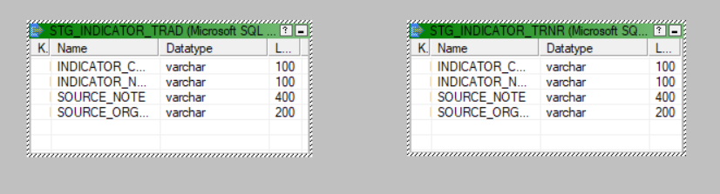

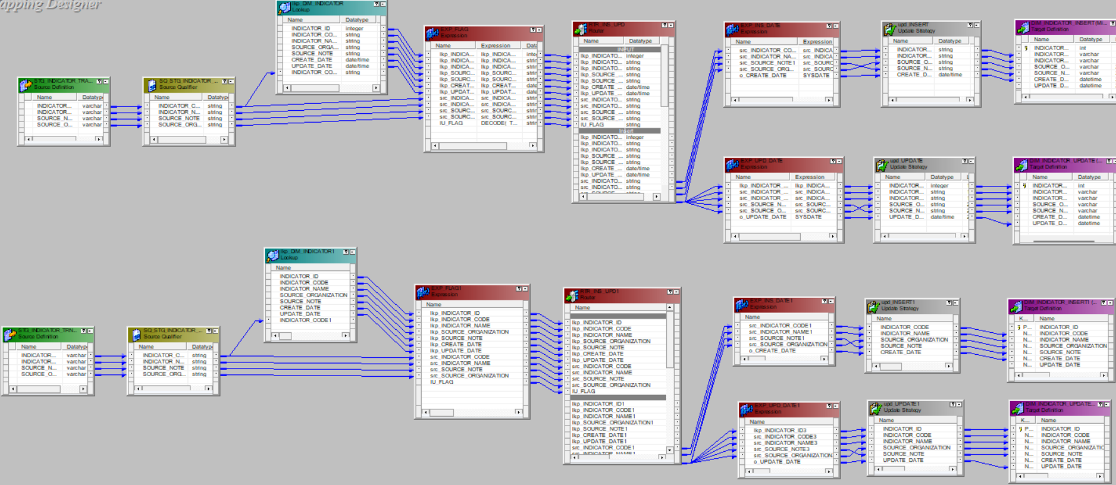

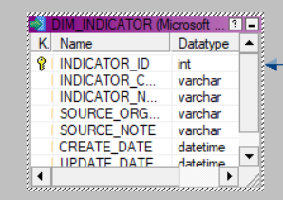

**8. From Staging to Fact Table (FACT_TRADE):**

From STG_TRAD to FACT_TRADE:

* For STG_TRAD, we perform Lookups on the DIM_COUNTRY, DIM_YEAR, and DIM_INDICATOR tables to get the COUNTRY_ID, YEAR_ID, and INDICATOR_ID, respectively.
* The TRADE_VALUE from STG_TRAD is then combined with the COUNTRY_ID, YEAR_ID, and INDICATOR_ID to create a unique trade record.
* A Lookup transformation on the FACT_TRADE table is performed to check if the record already exists based on the combination of COUNTRY_ID, YEAR_ID, and INDICATOR_ID.
* An Expression transformation is used to determine whether the record should be inserted, updated, or deleted.
* The Router transformation is used to route records based on the action (insert, update, delete), and the Update Strategy transformation is used to specify the operation for each record.
* Finally, the transformed records are processed and inserted into the FACT_TRADE table.

From STG_TRNR to FACT_TRADE:

* The process for STG_TRNR to FACT_TRADE is similar to STG_TRAD, with the same steps of performing Lookups on DIM_COUNTRY, DIM_YEAR, and DIM_INDICATOR to get the relevant IDs.
* An additional Lookup on the FACT_TRADE table is performed to check for existing records.
* Expression and Router transformations are used to handle inserts, updates, and deletes, followed by the Update Strategy transformation.
* Finally, records are inserted into FACT_TRADE.

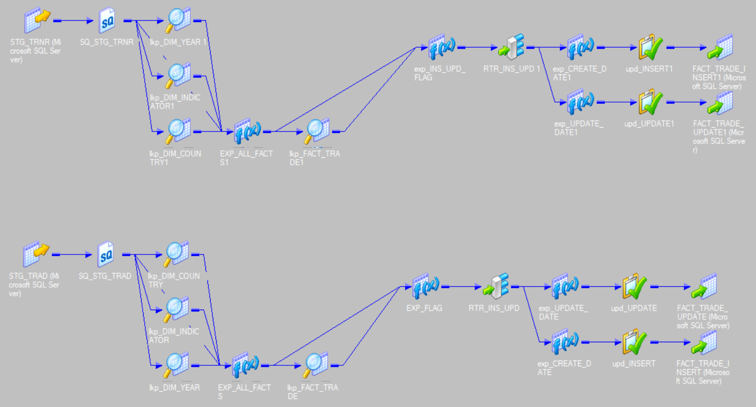

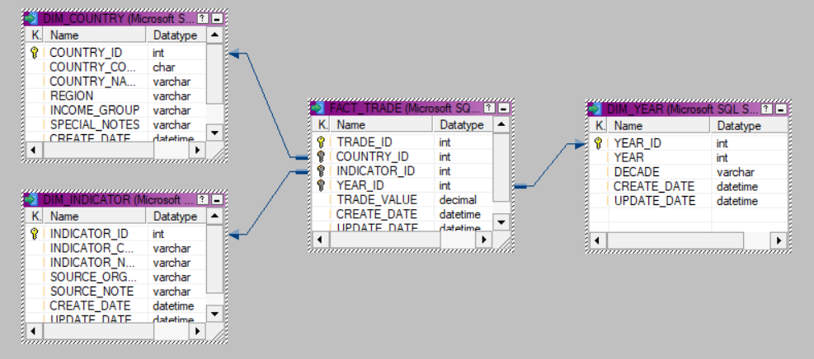

**Workflow Diagram –**

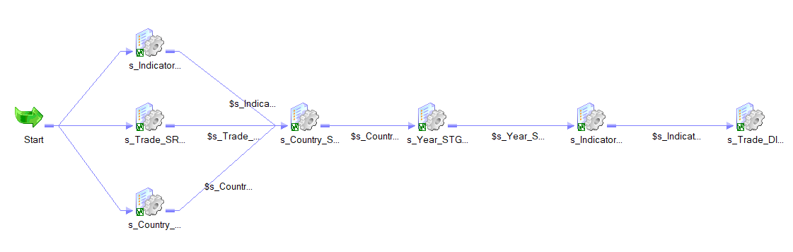

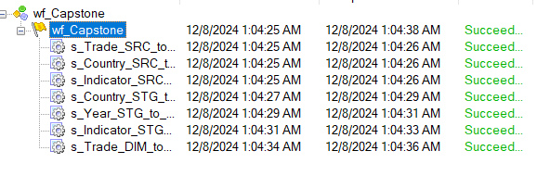

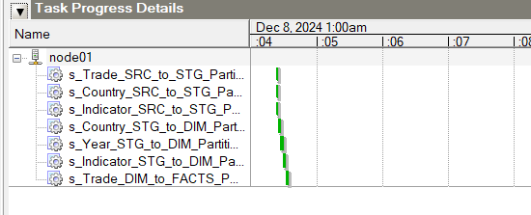

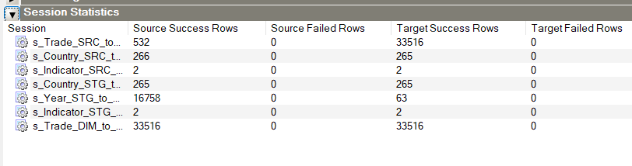

**Workflow Parameters –**

* Parameter File has been provided in the folder
* Parameter usage instances –

